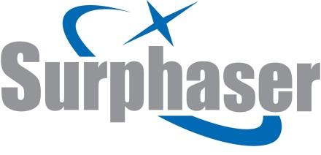

Calibration of vessel tanks with the use of 3D laser scanning

The purpose of the calibration is to make standard reference tables, which allow one to determine the amount of fluid in the tank depending on the filling level with due consideration of the vessel careen and trim difference.
As a rule, the calibration is based on the filling method using high-precision flowmeters. It is a very time and labor-consuming process.
The use of 3D laser scanning for measuring tanks enables to essentially increase the calibration rate with a high degree of reliability. For these purposes we use the Surphaser® 25HSX IR_X 3D scanner provides high accuracy (less than 1 mm) at a high scanning rate (216.000 points per second).

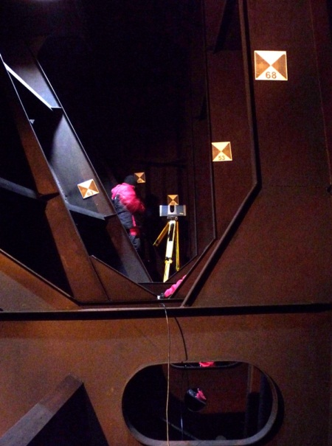  Fig.1. Scanning the vessel tank | The scanning results in a high-density point array, so called point cloud. The tank is scanned from different positions, and then the resulted data are registered in the single coordinate system.
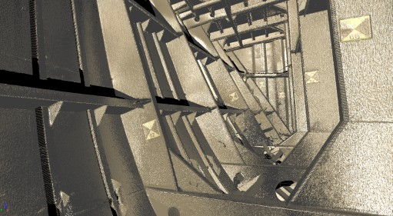  Fig. 2. Scan data – point clouds | Based on these data (point cloud) we create a closed 3D model of the tank which includes all the projecting components of the vessel and internal pipelines.

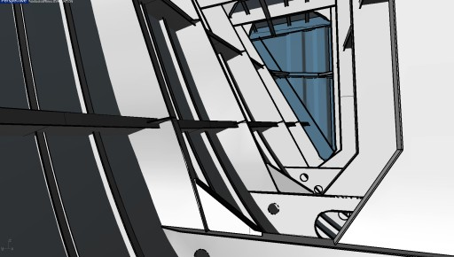  Fig. 3. 3D model of the tank created on the scanning data | Then, using the 3D model the volumes are automatically calculated as a function of the filling level changing with a given increment.
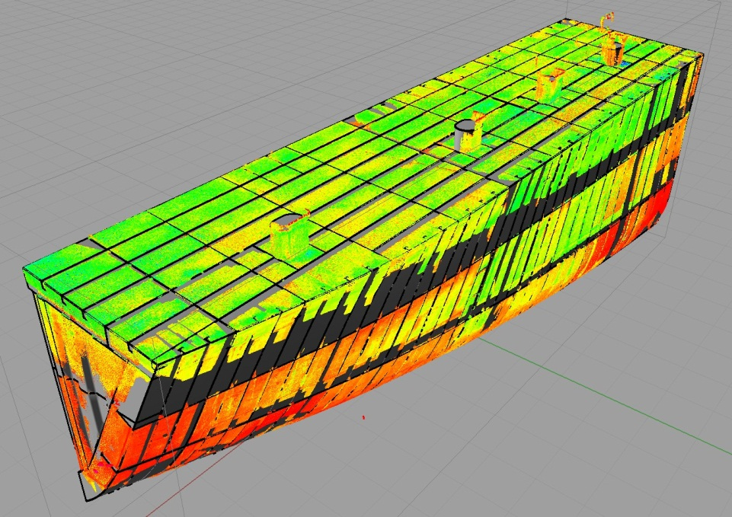  Fig. 4. 3D model of the tank combined with the initial point cloud, general view | The software used for 3D modeling and calculations of the volume: Rhinoceros 3D, Pointools 4 Rhino

Benefits:

- precise calculation of volumes for objects of any form
- minimum time needed for on-site works
- high precision and reliability of results.

