Laser 3D scanning of turbine wheels

The laser 3D scanning technology allows one to measure remotely the spatial coordinates of the great amount of points on the object surface, which fall within the scanning range. Data obtained in the scanning is a high-density array of points, so called point cloud.

This technology provides for monitoring the geometrical characteristics of the most complex objects:
- comparing physical object with its theoretical model
- measuring actual dimensions
- generating drawings and cross-sections
- creating as-built 3D models.

As a rule, a scan made from one viewpoint is not enough, as only a visible part of surfaces to be scanned falls within the working range of the scanner. Therefore, one should make scans from various scanner positions. Then different scans are registered into a single coordinate system using special registration marks, the coordinates of which are determined with a higher accuracy.

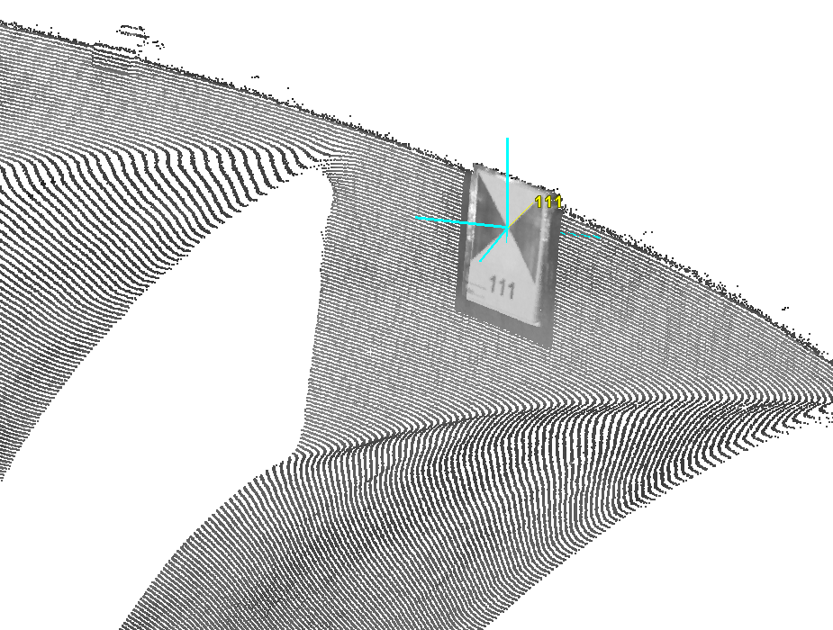
Point cloud and black-and-white registration mark with the recognized center

We have used the 3D laser scanning for measuring the turbine working wheels: the temporary РО-200 and the fixed РО-320.

High-speed Surphaser 25 HSX 3S scanner was used for this purpose. The device uses the polar principle to determine point coordinates: the high-precision angular sensors measure horizontal and vertical angles while the phase laser range unit measures distances.

Turbine wheel РО-200

The object was scanned from 19 various scanner positions (3 scans -- inside the wheel, and 16 scans -- outside). 43 registration marks were used to register the scans in the single coordinate system. In the total, 84 million points were measured on the surfaces of the turbine wheel and the shaft.

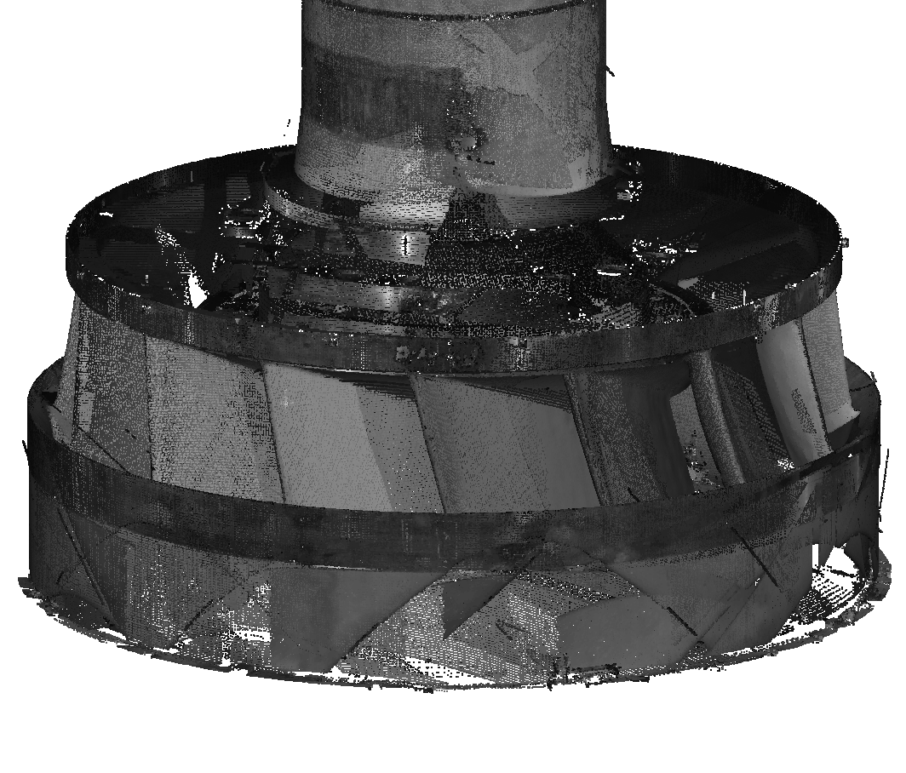
General view of the point cloud of the PO-200 turbine wheel

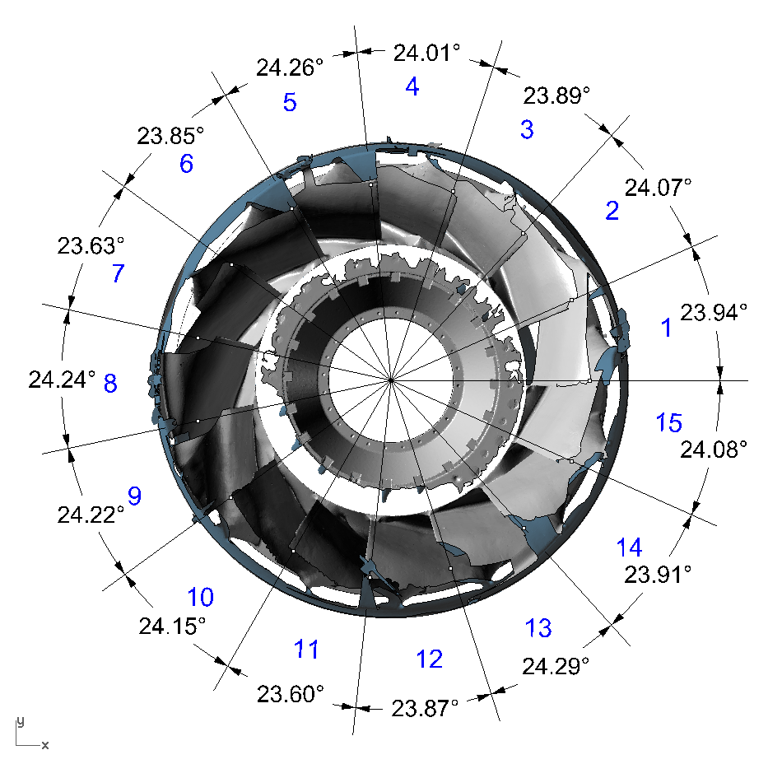
Angles between the axial lines of the РО-200 turbine wheel vanes

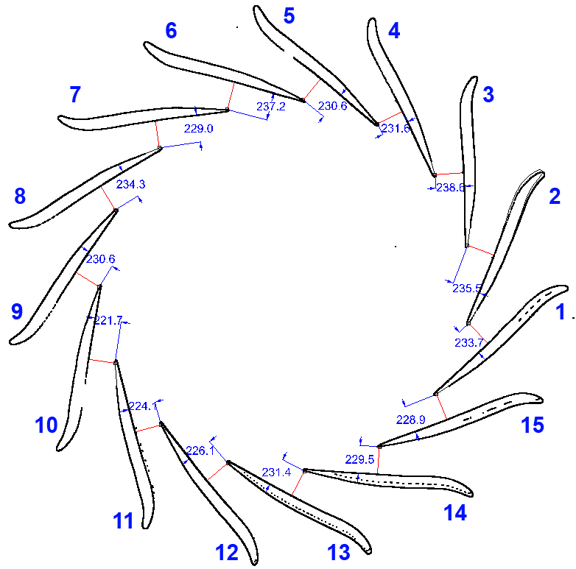

The least distances between cross-sections of PO-200 wheel vanes in the plane Z=700 mm

Turbine wheel РО-320

The object was scanned from 20 different scanner positions (2 scans -- inside the wheel, and 18 scans -- outside). 83 registration marks were used to register the scans. In the total, 83 million points were measured on the surfaces of the turbine wheel.

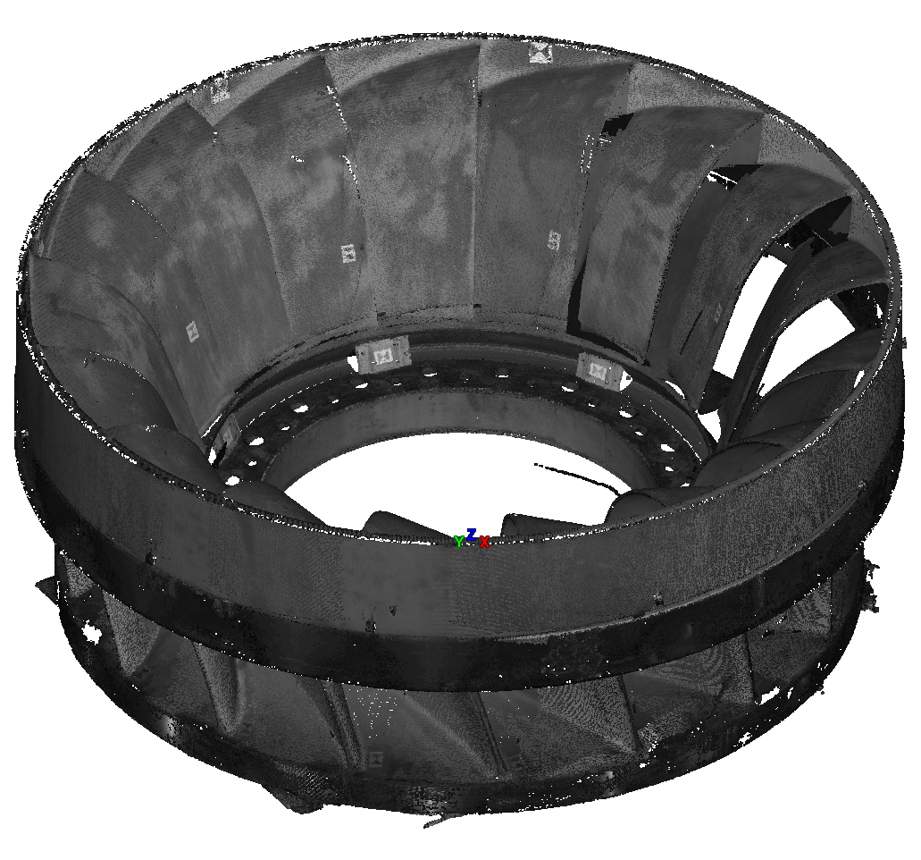
General view of the point cloud of the РО-320 turbine wheel

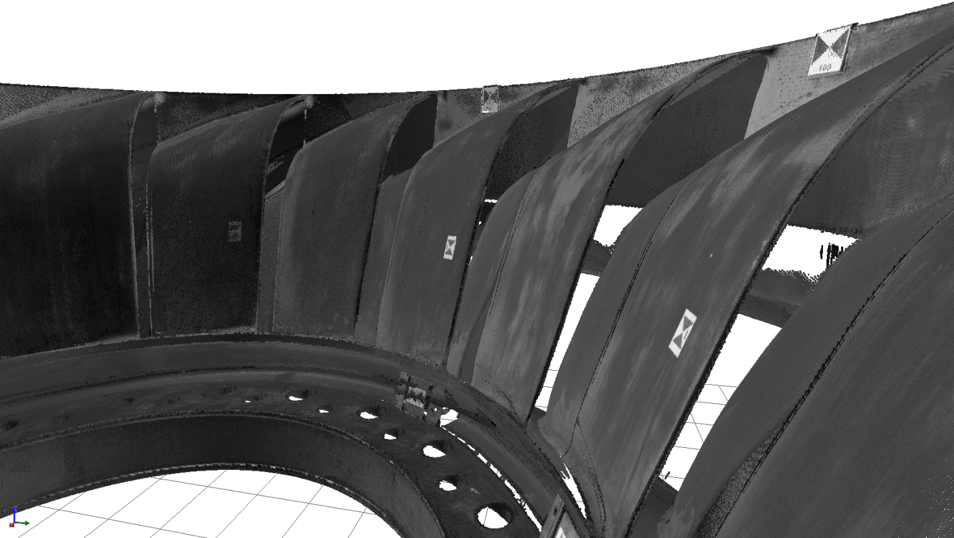

Point cloud of the PO-320 wheel, inside view
Angles between the axial lines of the PO-320 turbine wheel

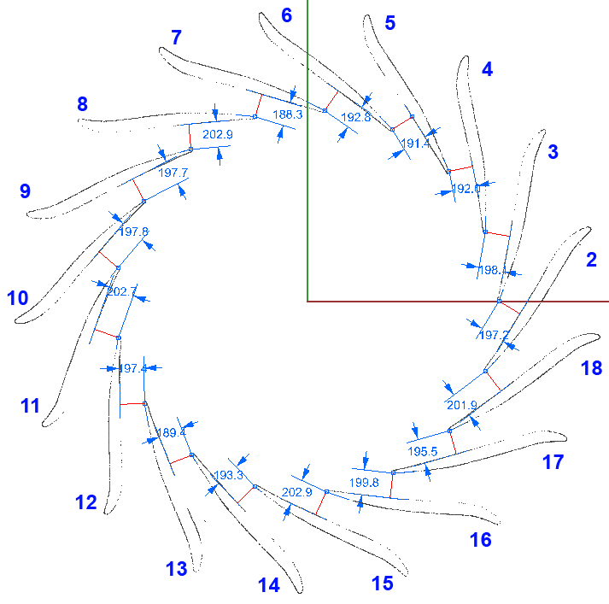

The least distances between cross-sections of PO-320 wheel vanes in the plane Z=700 mm

